Link to download Java SDK

<https://www.oracle.com/technetwork/java/javase/downloads/jdk13-downloads-5672538.html>

Link to download SOLR

<http://archive.apache.org/dist/lucene/solr/>

<http://archive.apache.org/dist/lucene/solr/8.3.1/>

1. Install Jdk
2. Install Jre
3. Update Java Home path in Environment Variables
4. Install Solr
5. To start Solr : Run cmd “C:\solr\solr-8.3.1\bin” -p 8984
   1. In browser ping localhost:8984
6. Next, we have to secure the SOLR

In cmd go to root directory of SOLR and then execute

“C:\Program Files\Java\jre1.8.0_231\bin\keytool.exe" -genkeypair -alias solr-ssl -keyalg RSA -keysize 2048 -keypass secret -storepass secret -validity 9999 -keystore solr-ssl.keystore.jks -ext SAN=DNS:localhost,IP:127.0.0.1 -dname "CN=localhost, OU=Organizational Unit, O=Organization, L=Location, ST=State, C=Country"

This commend created a keystore

1. Now pass the keystore to create the certificate

"C:\Program Files\Java\jre1.8.0_231\bin\keytool.exe" -importkeystore -srckeystore solr-ssl.keystore.jks -destkeystore solr-ssl.keystore.p12 -srcstoretype jks -deststoretype pkcs12 -srcstorepass secret -deststorepass **secret**

Secret is the key

1. Now we have to install the created certificate
   1. Select local machine on clicking the certificate and give the password as secret
   2. 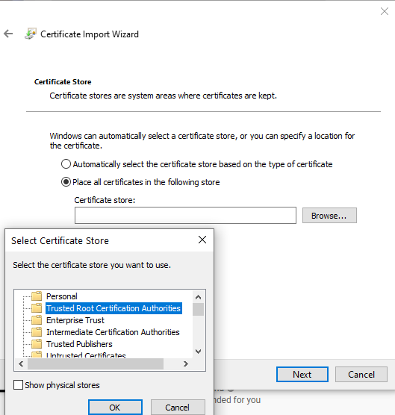 select this
   3. Move keystore and certificate into solr folder C:\solr\solr-8.3.1\server\etc
   4. Enable SSL in solr, for that go to bin folder, open solr.in file in notepad

Go to REM Enables HTTPS. It is implictly true if you set SOLR_SSL_KEY_STORE. Use this config

REM to enable https module with custom jetty configuration.

REM set SOLR_SSL_ENABLED=true

REM Uncomment to set SSL-related system properties

REM Be sure to update the paths to the correct keystore for your environment

REM set SOLR_SSL_KEY_STORE=etc/solr-ssl.keystore.jks

REM set SOLR_SSL_KEY_STORE_PASSWORD=secret

REM set SOLR_SSL_TRUST_STORE=etc/solr-ssl.keystore.jks

REM set SOLR_SSL_TRUST_STORE_PASSWORD=secret

REM Require clients to authenticate

REM set SOLR_SSL_NEED_CLIENT_AUTH=false

REM Enable clients to authenticate (but not require)

REM set SOLR_SSL_WANT_CLIENT_AUTH=false

REM Verify client hostname during SSL handshake

REM set SOLR_SSL_CLIENT_HOSTNAME_VERIFICATION=false

REM SSL Certificates contain host/ip "peer name" information that is validated by default. Setting

REM this to false can be useful to disable these checks when re-using a certificate on many hosts

REM set SOLR_SSL_CHECK_PEER_NAME=true

REM Override Key/Trust Store types if necessary

REM set SOLR_SSL_KEY_STORE_TYPE=JKS

REM set SOLR_SSL_TRUST_STORE_TYPE=JKS

**Remove rem from rows until set SOLR_SSL_WANT_CLIENT_AUTH=false**, next to REM(only for the commands) Be sure to update the paths to the correct keystore for your environment

set SOLR_SSL_TRUST_STORE_TYPE=JKS

1. Now close cmd and try pinging in new cmd (no need to cd) <https://localhost:8984/solr/#/> secured.

Now setup SOLR to run as a windows service

1. Download NSSM <https://nssm.cc/release/nssm-2.24.zip>
2. Move NSSM files to SOLR folder, not into the version

Run this is new cmd

“C:\solr\nssm-2.24\win64\nssm.exe” install SOLR8.3.1

1. Set Application path to be C:\solr\solr-8.3.1\bin\solr.cmd

Startup directory

Arguments start -f -p 8983 (port on which SOLR will run)

1. Finally, open services app and search for solr and start the service